Name Ideas

* Orderway
* ChequeIt
* MenuHub
* Sirvice
* Assistance
* OrderMate
* **MenuMate**
* ChequeMate
* OrderOrder
* OrderOut – This is the winner
* ChowedOut

Icon Ideas



Theme Color

|  |
| --- |
|  |
|  |
|  |
|  |
|  |
| Not great because light |
|  |
| Winner |

Theme Ideas

* Look at Uber eats and all. The navigation bar is not colored but the buttons and all are.
* No rounded corners.
* Only one screen coming from bottom.

Features/Challenges on user App

* People can look at menus of restaurants around them but they cannot order until they scan the qr code. Once they order using the qrcode. They have to pay using the app. Otherwise restaurants will force them to pay through themselves. Also anyone can order without paying.
* Camera that scans QR code
* Menu Display from the side
* Order before should also be there when you are at the same restaurant.
* Notifications when you are near a restaurant and you should use the application.
* Reviews
* Show nutritional value, summary, ingredients lactose intolerant and all badges.
* Waiting time for each food
* Add to cart and show cart
* Payment Gateway
* Past orders
* Signing up/ Logging In (Only for payment)
* Mobile login, email login etc.
* Firebase
* Waiting Time for dishes
* Automatic payment when people leave the coordinates.
* Restaurant can update if something is sold out.
* After ordering people can rate the restaurant and orders and review.
* Tells how much each time each dish can take
* ~~Can provide the user an update that their dish is ready or dish being prepared~~
* User can chat with restaurant
* Restaurant can have different menus for different time of the day
* Restaurant can use their app to select dishes that are not available any more
* If something is ordered by mistake then user can chat through the app to get something cancelled. Only restaurant can do so.
* In the add to cart screen, user will have an option to split this dish with other people on the table.
* This new screen which shows everyone who is their on the table also shows that if you don’t see someone then ask them to scan the qr code.

Features/Challenges on restaurant App

Ideas about UI

Intro Screen

* The upper half of the screen will show camera with QRCode graphics.

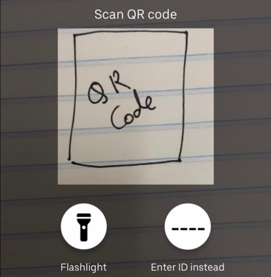

* The lower half will show nearby restaurants. This can be swiped up so should have a bar at the top and rounded corners at the top.
* People should also be given an option to enter ID rather than QR code.
* A flash button can be on the top right.
* An options button can be on top left.
* This options button will slide out options like uber.
* Notice the rest of the screen is blacked out.
* This slider options will contain
  + Photos and Name
  + Your orders
  + Help/About/Onboarding
  + Settings
* When main screen is pressed, the slider will close.

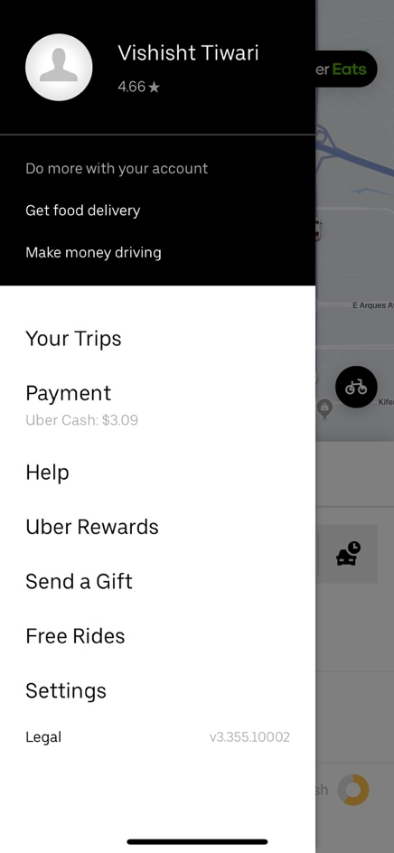

Restaurant Screen

* Shows different restaurants
* I like Deliveroo approach
* This screen will have a beautiful animation if no restaurants are available
* When you click restaurant, their menu will open

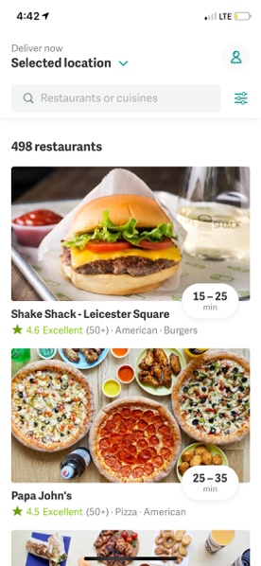

Menu Screen

* This will show the whole menu. Their can be a button on top left for reviews.
* Menu has been shown beautifully In, uber eats.
* I can outsource this screen to someone.
* This will also have a button at the top where users can ask questions and restaurant can respond through the application.

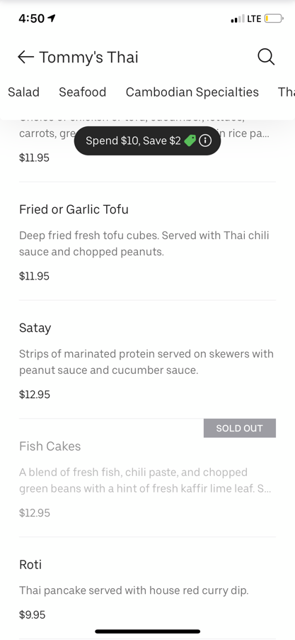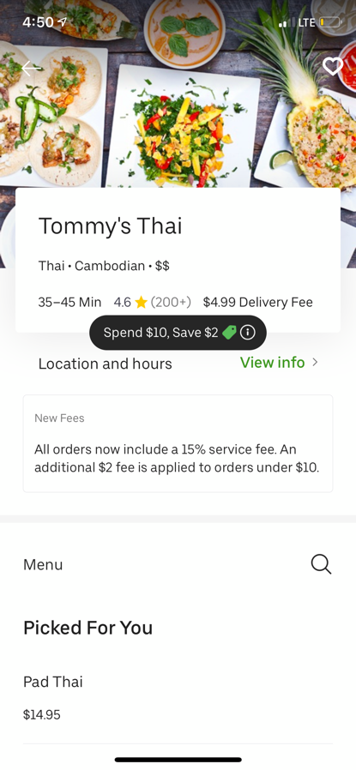

Dish Screen

* I liked hartaj’s implementation. Photos at the top. Then starts on the dishes, nutritional value, how to prounounce it, ingredients, badges of lactose and all, AR of the dish, waiting time then all the options that come with the dish. Special instructions also. Button at the bottom saying add to cart.
* If a dish wants to be changed then only the restaurant can cancel it, not the user.